**Assignment number - 2**

**1. WAP to find the duplicates present in an array.**

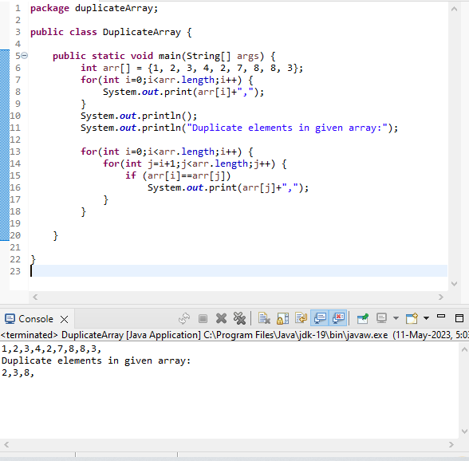

**2. WAP to sort an array using Quick Sort Algorithm.** 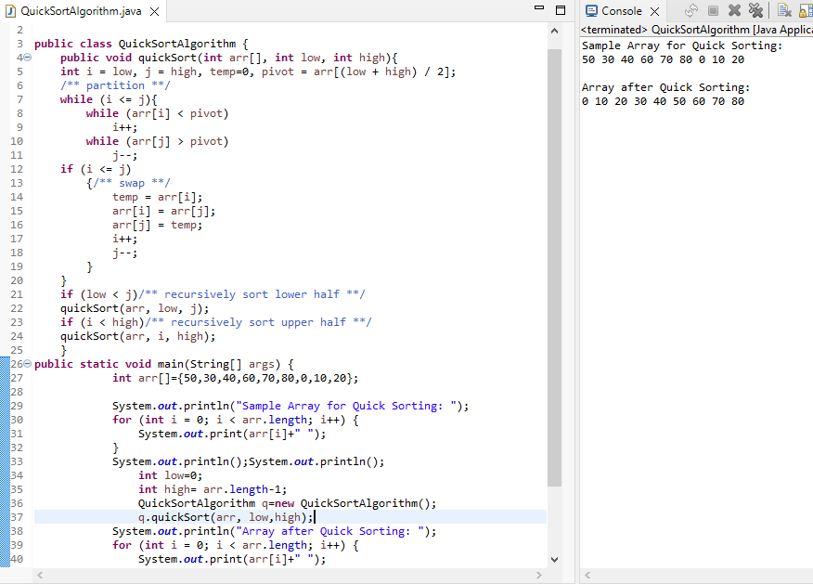

**3. WAP to sort an array using Bubble Sort Algorithm.**

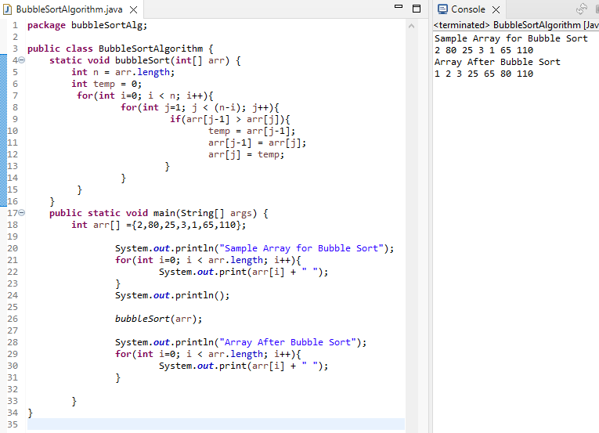

**4. WAP to sort an array using Merge Sort Algorithm.**

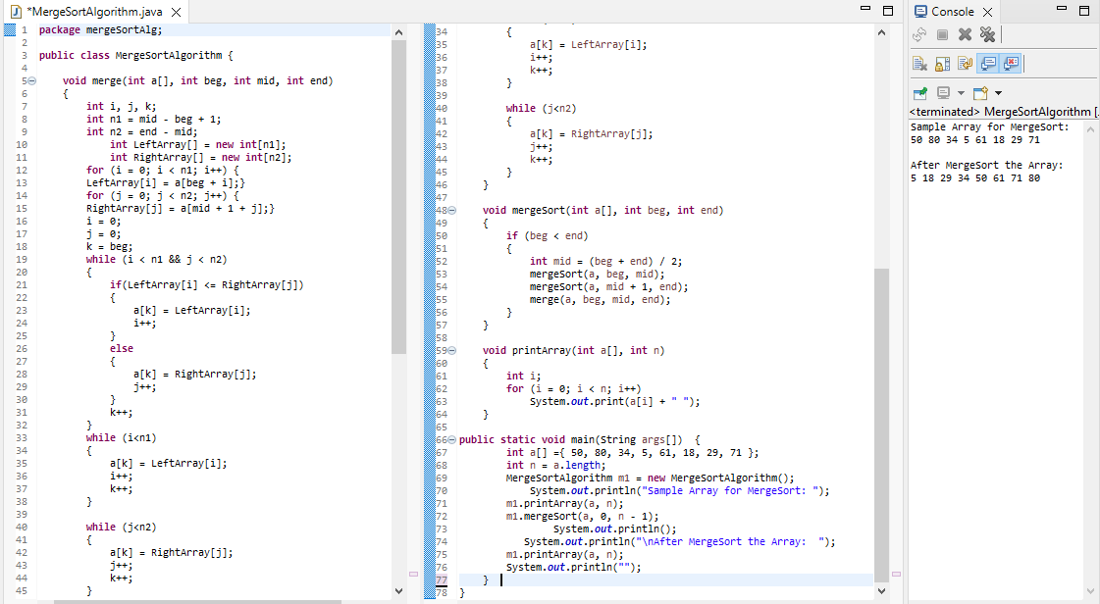

**5. WAP to sort an array using Selection Sort Algorithm.**

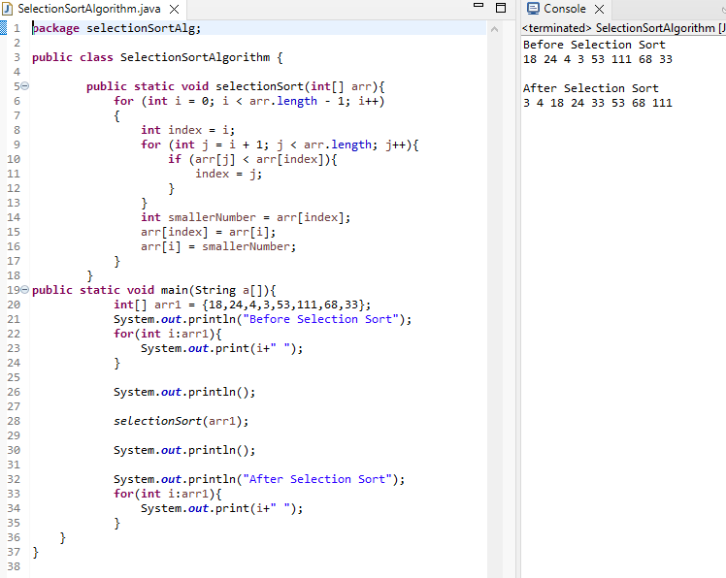

**6. WAP to check whether an array is a subset of another array.**

